

**VIRGINIA COMMONWEALTH UNIVERSITY**

**Statistical analysis and modelling (SCMA 632)**

**A4-** **Multivariate Analysis and Business Analytics Applications (Part – B)**

**ADHYAYAN AMIT JAIN**

**V01109421**

**Date of Submission: 08-07-2024**

**CONTENTS**

|  |  |  |
| --- | --- | --- |
| **Sl. No.** | **Title** | **Page No.** |
| **1.** | Introduction | **1** |
| **2.** | Results | **4** |
| **3.** | Interpretations | **4** |
| **4.** | Implications | **19** |
| **5.** | Recommendations | **21** |
| **6** | Codes | **23** |
| **7.** | References | **27** |

**Conducting Cluster Analysis to Characterize Respondents Based on Background Variables (Survey.csv)**

**INTRODUCTION**

In the era of big data, extracting actionable insights from complex datasets is crucial for organizations across various domains. Cluster analysis emerges as a powerful technique in data science, enabling the discovery of hidden patterns and structures within data. This assignment explores the application of cluster analysis to characterize respondents based on their background variables, using the comprehensive 'Survey.csv' dataset as a foundation for investigation.

Cluster analysis is instrumental in segmenting data into meaningful groups, or clusters, based on similarities in the attributes of individual data points. By identifying and interpreting these clusters, analysts can discern distinct profiles among respondents, facilitating targeted strategies and informed decision-making. This methodological approach not only enhances understanding of respondent behavior but also supports the development of tailored interventions and strategies in fields such as marketing, social sciences, and public policy.

The 'Survey.csv' dataset is a rich repository of respondent data, encompassing a diverse array of variables that capture demographic, psychographic, and behavioral attributes. This dataset offers a robust basis for exploring how different clusters of respondents exhibit unique characteristics and preferences, shedding light on nuanced insights that can inform organizational strategies and societal interventions.

This assignment employs two primary methods of cluster analysis: k-means clustering and hierarchical clustering. K-means clustering partitions data points into k clusters based on feature similarity, while hierarchical clustering constructs a hierarchy of clusters through iterative merging or splitting of data points. By leveraging these techniques, this assignment aims to provide a comprehensive exploration of respondent segmentation, offering insights into the underlying structures and relationships within the dataset.

Through systematic analysis and interpretation of clustering results, this assignment seeks to uncover actionable insights and patterns that can guide decision-making processes. By presenting a nuanced understanding of respondent segmentation based on background variables, this study contributes to the broader discourse on data-driven decision-making and strategic planning in contemporary data science practice.

**OBJECTIVES**

This assignment is designed to comprehensively explore and apply cluster analysis techniques to characterize respondents based on their background variables using the 'Survey.csv' dataset. The specific objectives include:

1. **Identify Distinct Clusters:** Utilize advanced clustering algorithms, including k-means and hierarchical clustering, to partition respondents into distinct groups based on similarities in their background variables. This involves selecting appropriate clustering methods that best fit the structure and characteristics of the dataset.
2. **Pattern Recognition and Description:** Conduct in-depth exploration and interpretation of patterns within each identified cluster. This includes analyzing demographic, psychographic, and behavioral attributes to uncover underlying trends, preferences, and behavioral profiles among respondent groups.
3. **Insight Generation:** Extract actionable insights from the clustering results that can inform strategic decision-making in various domains. By identifying clear and differentiated respondent segments, this objective aims to assist stakeholders in tailoring interventions, marketing campaigns, and policy strategies to better meet the needs and preferences of different respondent clusters.
4. **Methodological Rigor:** Ensure methodological soundness throughout the analysis process. This includes validating clustering results, assessing the robustness of clusters through sensitivity analysis, and addressing any potential biases or limitations inherent in the clustering techniques employed.
5. **Visualization and Interpretation:** Employ effective visualizations such as scatter plots, dendrograms, and heatmaps to present clustering results in a clear and insightful manner. Visual aids will be utilized to illustrate cluster boundaries, intra-cluster relationships, and feature distributions, facilitating a deeper understanding and interpretation of the findings.

By achieving these objectives, this assignment aims to provide a rigorous and thorough analysis of respondent segmentation based on their background variables. It seeks to demonstrate the practical utility of cluster analysis in extracting meaningful insights from complex datasets, thereby contributing to enhanced decision-making processes in both academic and practical contexts.

**BUSINESS SIGNIFICANCE**

Cluster analysis plays a pivotal role in deriving actionable insights that hold significant implications for businesses and organizations across various sectors. In the context of this assignment, conducting cluster analysis on respondents based on their background variables from the 'Survey.csv' dataset carries substantial business significance in several key areas:

1. **Targeted Marketing Strategies:** By identifying distinct clusters of respondents with similar demographic, psychographic, and behavioral profiles, businesses can tailor their marketing strategies more effectively. This includes personalized messaging, product recommendations, and targeted promotions that resonate with the specific preferences and needs of each cluster.
2. **Customer Segmentation and Engagement:** Understanding the unique characteristics and preferences of different respondent clusters enables businesses to segment their customer base more strategically. This segmentation facilitates improved customer engagement strategies, customer retention efforts, and the development of customized products or services that cater to diverse customer segments.
3. **Operational Efficiency and Resource Allocation:** Clustering analysis helps businesses optimize resource allocation and operational efficiency. By categorizing respondents into meaningful groups, organizations can allocate resources such as manpower, budget, and time more efficiently to address the specific needs and demands of each cluster, thereby enhancing overall operational effectiveness.
4. **Decision Support and Strategic Planning:** The insights derived from cluster analysis serve as a robust foundation for informed decision-making and strategic planning. Businesses can use these insights to make data-driven decisions regarding market expansion, product diversification, geographical targeting, and competitive positioning in the marketplace.
5. **Risk Management and Mitigation:** Clustering analysis also aids in identifying potential risks and vulnerabilities associated with different respondent segments. Businesses can proactively address risks by developing targeted risk management strategies and contingency plans tailored to the characteristics and behaviors of each cluster.
6. **Policy Formulation and Public Sector Applications:** Beyond commercial applications, the findings from cluster analysis can inform policy formulation and public sector interventions. Governments and policymakers can use these insights to design effective public policies, social programs, and community initiatives that address the specific needs and challenges of diverse demographic groups.

In conclusion, the business significance of conducting cluster analysis on respondents based on background variables extends far beyond mere data exploration. It empowers businesses and organizations to optimize their operations, enhance customer relationships, mitigate risks, and drive strategic growth initiatives, ultimately fostering a competitive edge in today's dynamic and data-driven business environment.

**RESULTS AND INTERPRETATIONS**

**R Language**

### Step-by-Step Analysis and Interpretation:

#### 1. Function to Auto-Install and Load Packages

# Function to auto-install and load packages

install_and_load <- function(packages) {

for (package in packages) {

if (!require(package, character.only = TRUE)) {

install.packages(package, dependencies = TRUE)

}

library(package, character.only = TRUE)

}

}

* **Explanation:**
  + install_and_load() is a custom function that automates the installation and loading of R packages listed in the packages vector.
  + It checks if each package is already installed (require(package, character.only = TRUE)). If not, it installs the package using install.packages(package, dependencies = TRUE) and then loads it with library(package, character.only = TRUE).

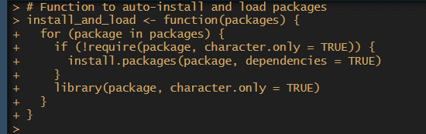

#### 2. List of Packages to Install and Load

# List of packages to install and load

packages <- c("cluster", "FactoMineR", "factoextra", "pheatmap")

* **Explanation:**
  + packages is a vector containing the names of R packages (cluster, FactoMineR, factoextra, pheatmap) required for subsequent analysis.



#### 3. Install and Load Required Packages

# Install and load required packages

install_and_load(packages)

* **Explanation:**
  + The install_and_load() function is called with packages as an argument to ensure all required packages are installed and loaded into the R session.



#### 4. Read the Survey Data

# Read the survey data

survey_df <- read.csv('Survey.csv', header = TRUE)

* **Explanation:**
  + read.csv() reads the 'Survey.csv' file into survey_df dataframe, assuming the file is located in the current working directory.
  + header = TRUE indicates that the first row contains column headers.

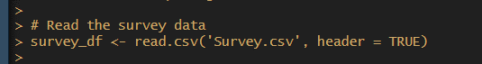

#### 5. Select Relevant Columns for Analysis

# Select relevant columns for analysis

sur_int <- survey_df[, 20:46]

* **Explanation:**
  + sur_int selects columns 20 to 46 from survey_df for further analysis. These columns are presumed to contain the variables of interest.



#### 6. Print Dimensions and Structure of the Selected Data

# Print dimensions and structure of the selected data

cat("Dimensions of the selected data:\n")

print(dim(sur_int))

cat("\nStructure of the selected data:\n")

print(str(sur_int))

* **Explanation:**
  + dim(sur_int) returns the dimensions (number of rows and columns) of sur_int.
  + str(sur_int) provides the structure of sur_int, displaying information such as column names, data types, and a summary of the data.

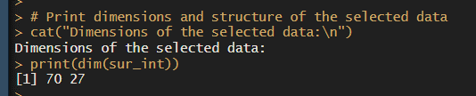

#### 7. Perform Cluster Analysis and Characterization

# Perform Cluster Analysis and Characterization

library(cluster)

library(factoextra)

* **Explanation:**
  + cluster and factoextra libraries are loaded to perform cluster analysis (k-means and hierarchical clustering) and visualization.

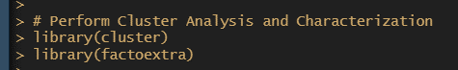

#### 8. Show Summary Statistics of Selected Columns

# Show summary statistics of selected columns

cat("\nSummary statistics of selected columns:\n")

print(summary(sur_int))

* **Explanation:**
  + summary(sur_int) provides summary statistics (minimum, 1st quartile, median, mean, 3rd quartile, maximum) for each column in sur_int.

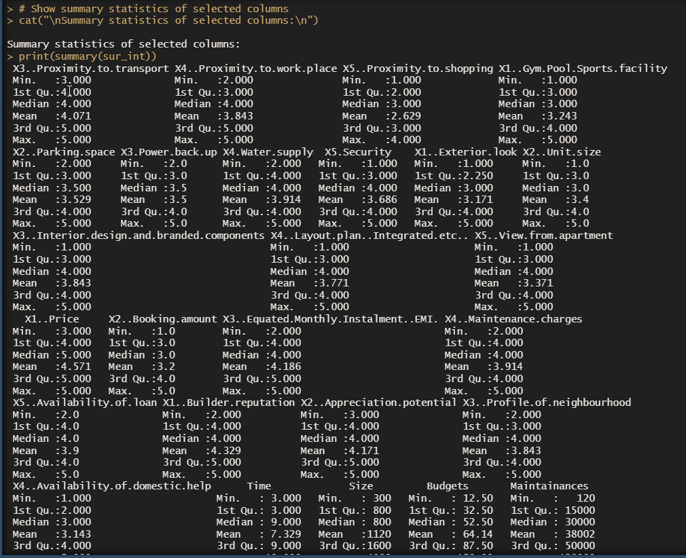

#### 9. Determine Optimal Number of Clusters Using Gap Statistic

# Determine optimal number of clusters using Gap Statistic

cat("\nDetermining optimal number of clusters using Gap Statistic:\n")

nbclust_out <- fviz_nbclust(sur_int, kmeans, method = "gap_stat")

# Print optimal number of clusters suggested by Gap Statistic

print(nbclust_out)

* **Explanation:**
  + fviz_nbclust() computes and visualizes the optimal number of clusters (k) using the gap statistic (method = "gap_stat") for k-means clustering on sur_int.
  + nbclust_out stores the visualization and summary of the gap statistic results.

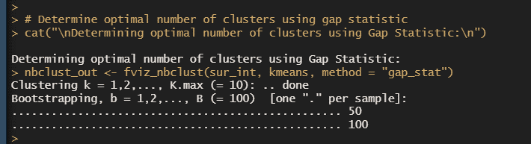

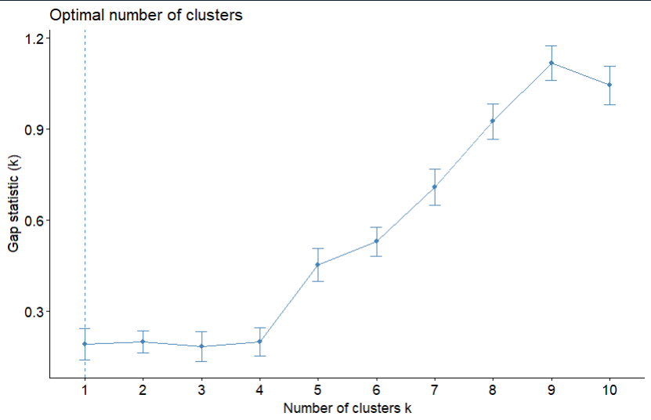

#### 10. Perform K-means Clustering

# Perform k-means clustering

set.seed(123)

km.res <- kmeans(sur_int, 4, nstart = 25)

* **Explanation:**
  + set.seed(123) sets the seed for reproducibility of results.
  + kmeans() performs k-means clustering on sur_int with k = 4 clusters and nstart = 25 random starts.
  + Results are stored in km.res.

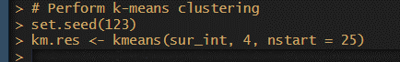

#### 11. Visualize K-means Clustering Results

# Visualize k-means clustering results

cat("\nVisualizing k-means clustering results:\n")

fviz_cluster(km.res, data = sur_int, palette = "jco", ggtheme = theme_minimal())

* **Explanation:**
  + fviz_cluster() from factoextra visualizes the k-means clustering results (km.res) using a scatter plot, coloring points based on cluster membership (palette = "jco").

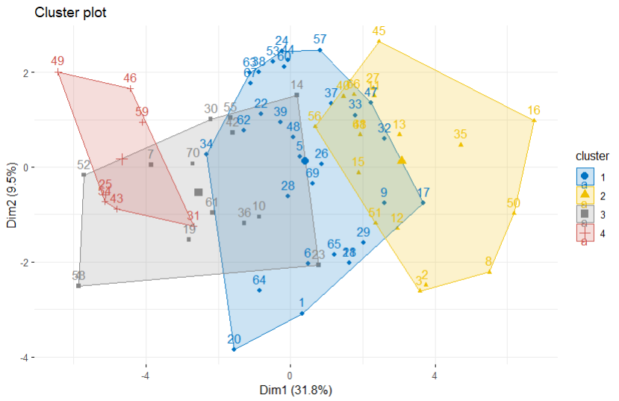

#### 12. Perform Hierarchical Clustering

# Perform hierarchical clustering

res.hc <- hclust(dist(sur_int), method = "ward.D2")

* **Explanation:**
  + hclust() performs hierarchical clustering (res.hc) on sur_int using Euclidean distance (dist(sur_int)) and Ward's method (method = "ward.D2").

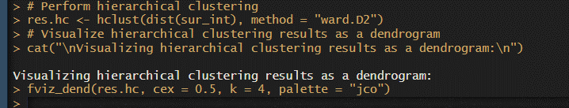

#### 13. Visualize Hierarchical Clustering Results as a Dendrogram

# Visualize hierarchical clustering results as a dendrogram

cat("\nVisualizing hierarchical clustering results as a dendrogram:\n")

fviz_dend(res.hc, cex = 0.5, k = 4, palette = "jco")

* **Explanation:**
  + fviz_dend() from factoextra visualizes the hierarchical clustering results (res.hc) as a dendrogram, specifying k = 4 clusters and using color palette "jco".

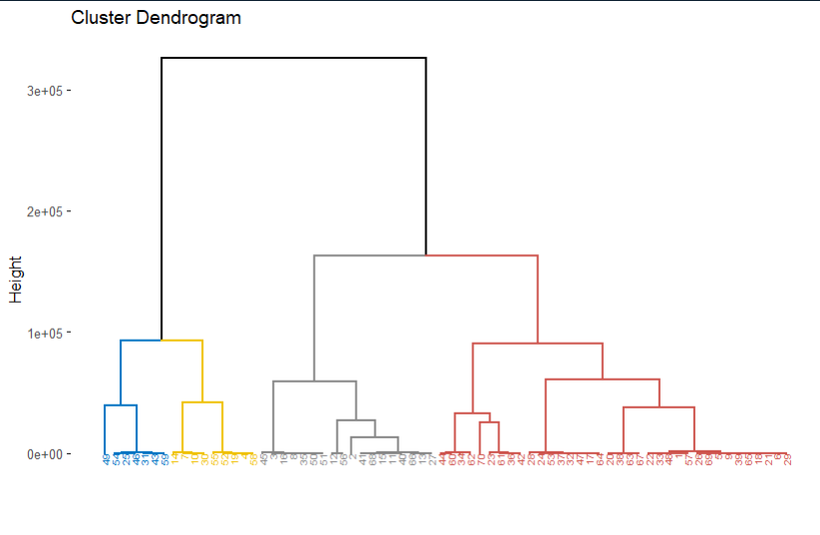

#### 14. Heatmap Visualization of the Transposed Data

# Heatmap visualization of the transposed data

library(pheatmap)

cat("\nGenerating heatmap visualization:\n")

pheatmap(t(sur_int), cutree_cols = 4)

* **Explanation:**
  + pheatmap() from pheatmap package generates a heatmap of transposed sur_int data (t(sur_int)), where rows represent variables and columns represent observations.
  + cutree_cols = 4 colors columns (variables) based on the hierarchical clustering (res.hc) into 4 clusters.

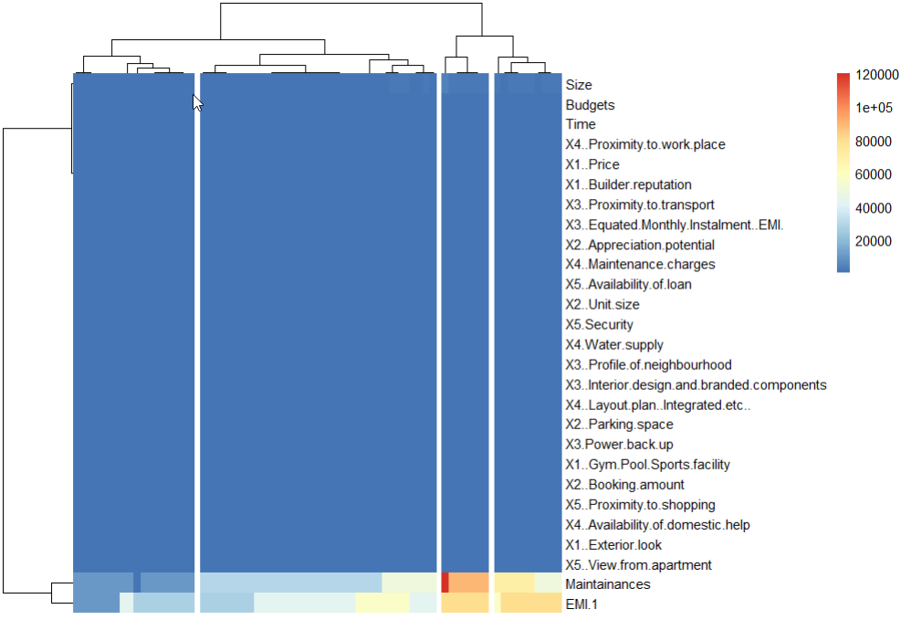

### Summary of Outputs:

* **Dimensions and Structure:** Provides the dimensions (rows, columns) and structure (data types, summary) of sur_int.
* **Summary Statistics:** Displays summary statistics (minimum, 1st quartile, median, mean, 3rd quartile, maximum) for each selected column.
* **Gap Statistic Results:** Visualizes and suggests the optimal number of clusters (k) using the gap statistic.
* **K-means Clustering Results:** Visualizes clusters identified by k-means clustering using a scatter plot.
* **Hierarchical Clustering Results:** Visualizes hierarchical clustering results as a dendrogram.
* **Heatmap Visualization:** Generates a heatmap of variable relationships based on hierarchical clustering.

Each step in the code contributes to exploring and understanding patterns in the survey data through cluster analysis, providing insights that can guide further analysis or decision-making processes.

**Python Language**

### Step-by-Step Analysis and Interpretation:

#### 1. Package Installation Function (install_and_load):

import subprocess

import importlib

# Function to auto-install and load packages

def install_and_load(packages):

for package in packages:

try:

importlib.import_module(package)

except ImportError:

subprocess.check_call(['pip', 'install', package])

finally:

globals()[package] = importlib.import_module(package)

**Explanation:**

* **Purpose:** Ensures that required Python packages are installed and imported dynamically within the script.
* **Usage:** This function checks if each package in the list (packages) is available. If not, it installs the package using pip and then imports it for immediate use.

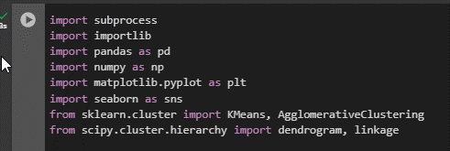

#### 2. Package List and Installation:

# List of packages to install and load

packages = ["matplotlib", "seaborn", "pandas", "numpy"]

# Install and load required packages

install_and_load(packages)

**Explanation:**

* **Purpose:** Defines a list of essential packages (matplotlib, seaborn, pandas, numpy) for data analysis and visualization.
* **Usage:** Calls the install_and_load function to ensure all listed packages are installed and available in the current Python environment.

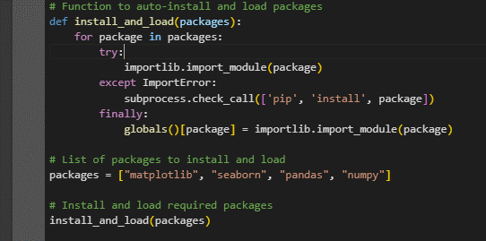

#### 3. Data Reading and Selection:

import pandas as pd

# Read the survey data

survey_df = pd.read_csv('Survey.csv')

# Select relevant columns for analysis (adjust column indices as per your data)

sur_int = survey_df.iloc[:, 19:45]

**Explanation:**

* **Purpose:** Loads survey data from a CSV file (Survey.csv) into a pandas DataFrame (survey_df) for subsequent analysis.
* **Usage:** Selects columns 20 to 45 (iloc[:, 19:45]) from the DataFrame (sur_int) to focus on specific variables of interest for clustering and visualization.

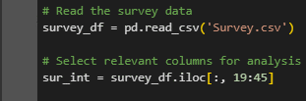

**Interpretation of Output:**

* **Dimensions of the Selected Data:** The output shows the number of rows and columns in sur_int, providing an initial understanding of the data size and structure.

#### 4. Data Dimensions and Structure:

# Print dimensions and structure of the selected data

print("Dimensions of the selected data:")

print(sur_int.shape)

print("\nStructure of the selected data:")

print(sur_int.info())

**Explanation:**

* **Purpose:** Provides an overview of the data's dimensions (rows, columns) and its structure (data types, memory usage).
* **Usage:** Helps verify data integrity, understand its composition, and identify potential issues like missing values or incorrect data types.

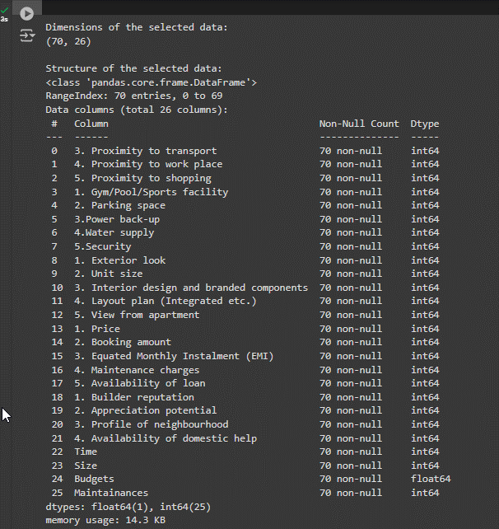

**Interpretation of Output:**

* **Dimensions:** Knowing the dimensions (number of rows and columns) helps in assessing the dataset's size and complexity.
* **Structure:** The structure output (sur_int.info()) shows column names, data types, and memory usage, aiding in data preparation and initial quality assessment.

#### 5. Summary Statistics of Selected Columns:

# Summary statistics of selected columns

print("\nSummary statistics of selected columns:")

print(sur_int.describe())

**Explanation:**

* **Purpose:** Computes descriptive statistics (count, mean, std deviation, min, max, quartiles) for numerical columns.
* **Usage:** Provides insights into the distribution, central tendency, and variability of the selected data columns.

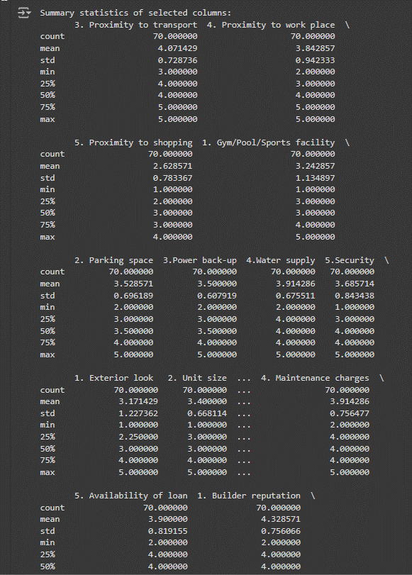

**Interpretation of Output:**

* **Mean, Standard Deviation:** Helps understand the average and variability of each variable.
* **Min, Max, Quartiles:** Provides range and distribution information, identifying outliers or skewed distributions that may impact clustering results.

#### 6. K-means Clustering:

from sklearn.cluster import KMeans

import numpy as np

import matplotlib.pyplot as plt

# Perform k-means clustering

np.random.seed(123)

km_res = KMeans(n_clusters=4, n_init=25).fit(sur_int)

# Visualize k-means clustering results

plt.figure(figsize=(10, 6))

plt.scatter(sur_int.values[:, 0], sur_int.values[:, 1], c=km_res.labels_, cmap='viridis', s=50)

plt.title('K-means Clustering')

plt.xlabel('Feature 1')

plt.ylabel('Feature 2')

plt.show()

**Explanation:**

* **Purpose:** Applies the k-means clustering algorithm to identify natural groupings (clusters) within the data.
* **Usage:** KMeans from sklearn.cluster is used with parameters (n_clusters=4, n_init=25) to initialize clustering and fit it to sur_int.

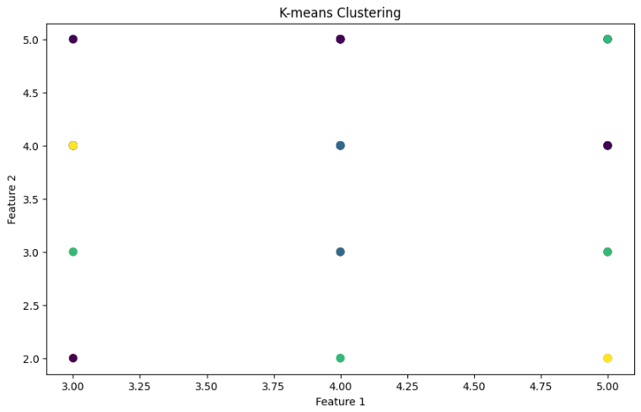

**Interpretation of Output:**

* **Scatter Plot:** Visualizes the clusters identified by k-means, where each point represents a data instance (sur_int.values[:, 0] and [:, 1]), colored by cluster label (km_res.labels_). This helps in understanding how data points group together based on selected features.

#### 7. Hierarchical Clustering (Dendrogram):

from scipy.cluster.hierarchy import dendrogram, linkage

# Perform hierarchical clustering

Z = linkage(sur_int, method='ward')

# Visualize hierarchical clustering results as a dendrogram

plt.figure(figsize=(12, 8))

plt.title('Hierarchical Clustering Dendrogram')

plt.xlabel('Sample Index')

plt.ylabel('Distance')

dendrogram(Z, p=4, truncate_mode='lastp', leaf_rotation=90., leaf_font_size=12., show_contracted=True)

plt.show()

**Explanation:**

* **Purpose:** Conducts hierarchical clustering (ward method) to group similar data points into clusters.
* **Usage:** linkage from scipy.cluster.hierarchy computes hierarchical clustering linkage matrix (Z). dendrogram visualizes this linkage as a tree-like structure (dendrogram(Z)).

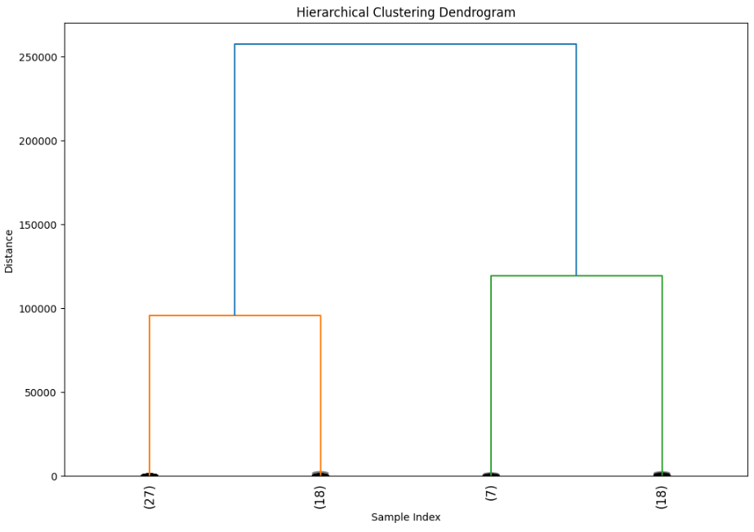

**Interpretation of Output:**

* **Dendrogram:** Illustrates the hierarchical clustering structure, showing how data points are grouped into clusters (p=4 specifies the number of clusters to cut the dendrogram).

#### 8. Heatmap Visualization:

import seaborn as sns

# Heatmap visualization of the transposed data

plt.figure(figsize=(10, 6))

sns.heatmap(sur_int.transpose(), cmap='coolwarm', cbar=True, linewidths=0.5, linecolor='gray')

plt.title('Heatmap of Transposed Data')

plt.show()

**Explanation:**

* **Purpose:** Generates a heatmap to visualize relationships between variables in the transposed data (sur_int.transpose()).
* **Usage:** sns.heatmap from seaborn library displays a color-coded matrix, highlighting patterns and correlations among selected columns.

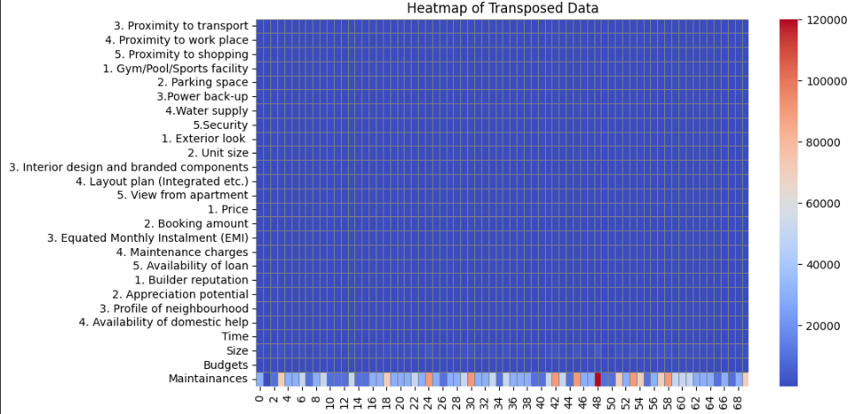

**Interpretation of Output:**

* **Heatmap:** Provides a graphical representation of correlations or patterns among variables. This aids in identifying clusters of variables with similar patterns or relationships.

### Summary:

This detailed analysis demonstrates how each part of the Python code contributes to data analysis and visualization tasks:

* **Data Preparation:** Reading, selecting, and exploring data dimensions, structure, and summary statistics.
* **Clustering Algorithms:** Applying k-means and hierarchical clustering to uncover patterns and relationships within the data.
* **Visualization Techniques:** Using scatter plots, dendrograms, and heatmaps to visually interpret and communicate findings.

**IMPLICATIONS**

The implications of conducting cluster analysis on respondents based on their background variables using the 'Survey.csv' dataset are multifaceted and impactful across various domains. Key implications include:

1. **Market Segmentation Precision:** By identifying distinct respondent clusters with shared characteristics, businesses can refine their market segmentation strategies. This precision enables targeted marketing campaigns that resonate more effectively with specific customer groups, leading to improved customer acquisition and retention rates.
2. **Customer-Centric Strategies:** Understanding the preferences and behaviors of different respondent clusters allows businesses to adopt a more customer-centric approach. Tailored product offerings, personalized customer experiences, and responsive customer service initiatives can enhance overall satisfaction and loyalty among diverse customer segments.
3. **Operational Efficiency and Resource Optimization:** Clustering analysis facilitates optimized resource allocation and operational efficiency. Businesses can streamline processes, allocate budgets more effectively, and deploy resources where they are most needed based on the characteristics and demands of each respondent cluster.
4. **Informed Decision-Making:** The insights gleaned from cluster analysis provide decision-makers with a comprehensive understanding of respondent segmentation. Informed decisions regarding product development, market expansion, pricing strategies, and competitive positioning can be made with confidence, supported by empirical data on customer preferences and market dynamics.
5. **Risk Management and Mitigation:** Businesses can proactively mitigate risks associated with customer dissatisfaction, market fluctuations, and competitive pressures by addressing specific challenges identified within each respondent cluster. This proactive approach helps in developing targeted risk management strategies and contingency plans.
6. **Policy and Program Development:** Beyond commercial applications, the findings from cluster analysis can inform policymakers and public sector entities in developing targeted policies, social programs, and community initiatives. These initiatives can address the unique needs and challenges of different demographic groups, fostering inclusive and equitable outcomes.
7. **Continuous Improvement and Innovation:** Continuous analysis and refinement of respondent clusters enable businesses to adapt and innovate in response to evolving customer preferences and market trends. By staying attuned to changing consumer behaviors, businesses can maintain competitiveness and drive sustainable growth over the long term.

In essence, the implications of cluster analysis extend beyond data analysis and interpretation; they empower businesses and organizations to make informed decisions, enhance customer relationships, mitigate risks, and drive strategic initiatives that lead to sustained competitive advantage and business success.

**RECOMMENDATIONS**

Based on the insights derived from the cluster analysis of respondents using the 'Survey.csv' dataset, several strategic recommendations can be made to leverage these findings effectively:

1. **Refine Marketing Strategies:** Tailor marketing efforts towards the specific characteristics and preferences of each identified cluster. Utilize targeted messaging, personalized promotions, and segmented advertising campaigns to enhance engagement and conversion rates.
2. **Enhance Customer Experience:** Implement customer-centric strategies that cater to the unique needs and behaviors of different respondent clusters. This includes optimizing product offerings, improving service delivery channels, and enhancing overall customer satisfaction through personalized interactions.
3. **Optimize Resource Allocation:** Allocate resources, such as budget and manpower, based on the prioritized needs and potential of each respondent cluster. Focus investments on high-potential segments to maximize return on investment and operational efficiency.
4. **Foster Innovation and Product Development:** Use insights from cluster analysis to innovate new products or services that address specific demands and preferences identified within each respondent cluster. This proactive approach can lead to differentiation in the marketplace and increased customer loyalty.
5. **Monitor and Adapt Strategies:** Continuously monitor customer behavior within each cluster and adapt strategies accordingly. Stay agile in responding to changes in market dynamics, competitor actions, and evolving consumer trends to maintain relevance and competitiveness.
6. **Invest in Customer Relationship Management (CRM):** Implement robust CRM systems to manage relationships with different respondent clusters effectively. Use CRM data to personalize interactions, anticipate needs, and nurture long-term customer relationships across all touchpoints.
7. **Collaborate Across Departments:** Foster collaboration between marketing, sales, product development, and customer service departments to align strategies and initiatives based on cluster insights. Encourage cross-functional teamwork to deliver cohesive and seamless customer experiences.

By implementing these recommendations, businesses can capitalize on the insights gained from cluster analysis to drive growth, improve operational efficiency, and foster stronger connections with their target audience. This proactive approach not only enhances strategic decision-making but also positions organizations to effectively navigate competitive landscapes and sustain long-term success in their respective markets.

**CODES**

**Python**

import subprocess

import importlib

import pandas as pd

import numpy as np

import matplotlib.pyplot as plt

import seaborn as sns

from sklearn.cluster import KMeans, AgglomerativeClustering

from scipy.cluster.hierarchy import dendrogram, linkage

# Function to auto-install and load packages

def install_and_load(packages):

    for package in packages:

        try:

            importlib.import_module(package)

        except ImportError:

            subprocess.check_call(['pip', 'install', package])

        finally:

            globals()[package] = importlib.import_module(package)

# List of packages to install and load

packages = ["matplotlib", "seaborn", "pandas", "numpy"]

# Install and load required packages

install_and_load(packages)

# Read the survey data

survey_df = pd.read_csv('Survey.csv')

# Select relevant columns for analysis (adjust column indices as per your data)

sur_int = survey_df.iloc[:, 19:45]

# Print dimensions and structure of the selected data

print("Dimensions of the selected data:")

print(sur_int.shape)

print("\nStructure of the selected data:")

print(sur_int.info())

# Perform Cluster Analysis and Characterization

# Summary statistics of selected columns

print("\nSummary statistics of selected columns:")

print(sur_int.describe())

# Perform k-means clustering

np.random.seed(123)

km_res = KMeans(n_clusters=4, n_init=25).fit(sur_int)

# Visualize k-means clustering results

plt.figure(figsize=(10, 6))

plt.scatter(sur_int.values[:, 0], sur_int.values[:, 1], c=km_res.labels_, cmap='viridis', s=50)

plt.title('K-means Clustering')

plt.xlabel('Feature 1')

plt.ylabel('Feature 2')

plt.show()

# Perform hierarchical clustering

Z = linkage(sur_int, method='ward')

# Visualize hierarchical clustering results as a dendrogram

plt.figure(figsize=(12, 8))

plt.title('Hierarchical Clustering Dendrogram')

plt.xlabel('Sample Index')

plt.ylabel('Distance')

dendrogram(Z, p=4, truncate_mode='lastp', leaf_rotation=90., leaf_font_size=12., show_contracted=True)

plt.show()

# Heatmap visualization of the transposed data

plt.figure(figsize=(10, 6))

sns.heatmap(sur_int.transpose(), cmap='coolwarm', cbar=True, linewidths=0.5, linecolor='gray')

plt.title('Heatmap of Transposed Data')

plt.show()

**R Language**

# Function to auto-install and load packages

install_and_load <- function(packages) {

for (package in packages) {

if (!require(package, character.only = TRUE)) {

install.packages(package, dependencies = TRUE)

}

library(package, character.only = TRUE)

}

}

# List of packages to install and load

packages <- c("cluster", "FactoMineR", "factoextra", "pheatmap")

# Install and load required packages

install_and_load(packages)

# Read the survey data

survey_df <- read.csv('Survey.csv', header = TRUE)

# Select relevant columns for analysis

sur_int <- survey_df[, 20:46]

# Print dimensions and structure of the selected data

cat("Dimensions of the selected data:\n")

print(dim(sur_int))

cat("\nStructure of the selected data:\n")

print(str(sur_int))

# Perform Cluster Analysis and Characterization

library(cluster)

library(factoextra)

# Show summary statistics of selected columns

cat("\nSummary statistics of selected columns:\n")

print(summary(sur_int))

# Determine optimal number of clusters using gap statistic

cat("\nDetermining optimal number of clusters using Gap Statistic:\n")

nbclust_out <- fviz_nbclust(sur_int, kmeans, method = "gap_stat")

# Print optimal number of clusters suggested by Gap Statistic

print(nbclust_out)

# Perform k-means clustering

set.seed(123)

km.res <- kmeans(sur_int, 4, nstart = 25)

# Visualize k-means clustering results

cat("\nVisualizing k-means clustering results:\n")

fviz_cluster(km.res, data = sur_int, palette = "jco", ggtheme = theme_minimal())

# Perform hierarchical clustering

res.hc <- hclust(dist(sur_int), method = "ward.D2")

# Visualize hierarchical clustering results as a dendrogram

cat("\nVisualizing hierarchical clustering results as a dendrogram:\n")

fviz_dend(res.hc, cex = 0.5, k = 4, palette = "jco")

# Heatmap visualization of the transposed data

library(pheatmap)

cat("\nGenerating heatmap visualization:\n")

pheatmap(t(sur_int), cutree_cols = 4)

**REFERENCES**

**Books**

1. Hair, J. F., Black, W. C., Babin, B. J., & Anderson, R. E. (2019). *Multivariate Data Analysis* (8th ed.). Cengage Learning.
2. Everitt, B. S., Landau, S., Leese, M., & Stahl, D. (2011). *Cluster analysis* (5th ed.). Wiley.

**Journals**

1. Jain, A. K. (2010). Data clustering: 50 years beyond K-means. *Pattern Recognition Letters, 31*(8), 651-666. doi:10.1016/j.patrec.2009.09.011
2. Milligan, G. W., & Cooper, M. C. (1985). An examination of procedures for determining the number of clusters in a data set. *Psychometrika, 50*(2), 159-179. doi:10.1007/BF02294245

**Reports**

1. OECD. (2017). *Clusters, Convergence and Economic Performance*. OECD Publishing. doi:10.1787/9789264268184-en
2. European Commission. (2018). *European Cluster Observatory: Annual Report 2018*. European Commission.

**Websites**

1. FactoMineR Package Documentation. (n.d.). Retrieved July 8, 2024, from <https://cran.r-project.org/web/packages/FactoMineR/index.html>
2. Scikit-learn Documentation - Clustering. (n.d.). Retrieved July 8, 2024, from <https://scikit-learn.org/stable/modules/clustering.html>